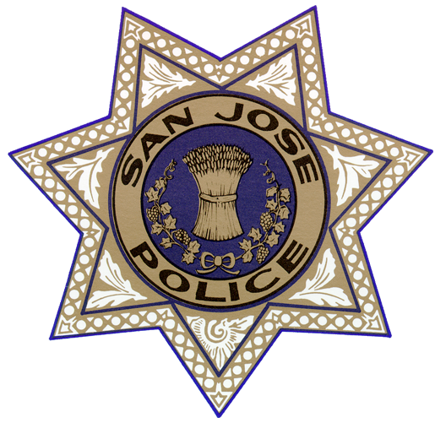

Communications Training Officer Course

**Communications Training Officer Course**

**Date:** March 13 – March 17, 2023 from 0700-1600 with 1-hour lunch (40 Hours)

**Course Location:** Chaplain Dave Bridgen Southern Police Substation

6087 Great Oaks Parkway San Jose, Ca 95119

**CA POST Certified Plan IV:** CCN 1124-30960-22-002

**Fee:** $170

**Registration due by: Friday March 3, 2023**

This Course is designed to train newly appointed Communications Training Officers (CTO). They will receive training in leadership, roles and duties of a CTO, adult learning concepts and teaching techniques. They will also receive training on generations in the workplace, legal and liability issues, evaluation procedures, documenting performance, counseling methods and remediation. The curriculum is designed to assist CTOs in becoming fair, competent Communications Training Officers for their agencies.

**Registration questions please contact:**

Jennifer Vasquez, Supv. PSD Training Unit Manager

San Jose Police Communications Training Unit

408-537-1740 or [jennifer.vasquez@sanjoseca.gov](mailto:jennifer.vasquez@sanjoseca.gov)

To pay **by credit card contact South Bay Regional Training at 408-229-4299 and reference the March CTO Course.**  Paying by check, make payable to **South Bay Regional and mail to:** Jennifer Vasquez

San Jose Police Communications

855 N. San Pedro St. 4th Floor

San Jose, Ca 95110